Executive Summary
This pilot program, implemented across three sites (RMN3, SWF2, and VGT2), aims to optimize operational efficiency and quality metrics through a two-phase deployment of SAM and 1-to-1 staging initiatives. Phase 1 focuses on SAM implementation, which will streamline dock operations by converting indirect waterspiders to direct pallet movement positions, thereby reducing labor overhead. Phase 2 introduces 1-to-1 staging processes, complemented by Quicksight monitoring capabilities for dwell time tracking. The program serves dual objectives: operationally, it targets workforce optimization and reduction of unknown idle time; from a quality standpoint, it enhances freight visibility and reduces dwell times, leading to improved GIA and UCO metrics. This comprehensive approach represents a strategic shift toward more efficient dock management and quality control systems.
Schedule
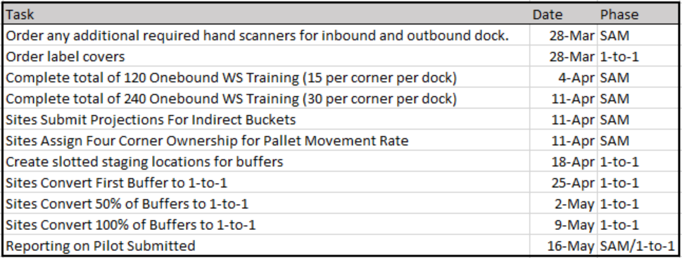
Figure 1: SAM Pilot Schedule
This Quip will be utilized for tracking task completion. The two phases (SAM and 1-to-1 staging) have some tasks interleaved to shorten the turnaround time for the overall rollout.
SAM Rollout
SAM may require sites to order additional hand scanners if they are not already utilized by waterspiders on Inbound and Outbound docks. If necessary, sites should input the number of hand scanners required, indicate when the order has been submitted, and input the ticket for the order into the SAM Pilot Tracker.
The expectation is that within two weeks following the initial meeting on 03/21, sites will have their first 120 Onebound WS Trainings completed (by 04/04). Then by the next week, the expectation is that sites will complete another 120 Onebound WS Trainings (by 04/11).
To project the reduction in indirect headcounts, site will specify in the SAM Pilot Tracker which indirect buckets the applicable waterspiders (moving pallets on IB and OB Dock) are currently being coded into and what the expected reduction in headcount for those buckets will be. Sites will assign four corner owners to implement control mechanisms to ensure the waterspider headcount is being accounted for in the pallet movement bucket and idle time in those buckets is being monitored. These cost owners will have two objectives: 1) Reduce indirect headcount; 2) Increase direct rate.
As soon as scanners are available on site, sites are expected to have their newly trained Onebound Waterspiders in the Pallet Movement function.
1-to-1 Staging Rollout
In pre-pilot resting, it was determined that a barrier to 1-to-1 staging was label durability. Sites should order label covers no later than 03/28 to allow for any delays in shipping.
Deliverables for 1-to-1 staging will pick back up on 04/18, when sites are expected to have created slotted staging locations for each buffer. A video tutorial should be available for this no later than 03/28.
The rollout of 1-to-1 to the floor will be done in phases. Initially, sites are expected to trial converting one buffer to 1-to-1 (by 04/25). Sites will then convert 50% of EOL buffers to 1-to-1 (by 05/02). Full rollout is expected to be complete by 05/09. During the buffer conversions, pilot teams will be meeting weekly to discuss an associate or leadership feedback, and the durability of the pallet locations will be monitored continuously.
Dwelling Containers Quicksight
This Quicksight will be leveraged for monitoring and reducing outbound dock dwells. Standard work will be developed and rolled out during this pilot in tandem with 1-to-1 rollout with the goal of reducing UCO originating from EOL and OB Dock.
Links
SAM Pilot Tracker
Onebound Waterspider Training
Label Covers Link

